**MARKET ANALYSIS REPORT ON NATIONAL CLOTHING CHAIN**

Prepared by: Abdullah Sagheer  
Submitted to Udacity as part of the graduation requirements

Date: 28/9/2023

* Introduction:

The National Clothing Chain aims to develop a focused marketing strategy in response to stagnant sales and the goal of reengaging with previous customers. Their objective is to determine the most suitable products to promote to specific customers in various locations. To achieve this, they gathered data from sources such as the US Census Bureau, Business Data, and Customer Data. Subsequently, they meticulously processed, structured, and analyzed this data with the assistance of Power BI to address the challenges confronting the National Clothing Chain.

* Findings:

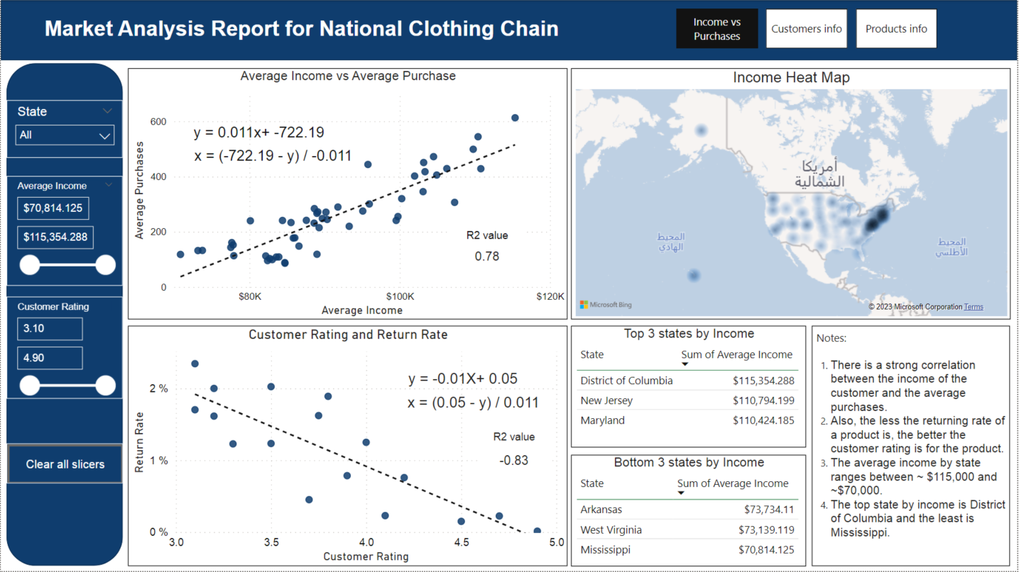

Figure 1: Report's First Page

* The relationship between the Sales and the average income was analyzed. It was found that there is a positive correlation between the two parameters; the number of purchases increase when the income increases. This was deemed as a strong correlation since the .

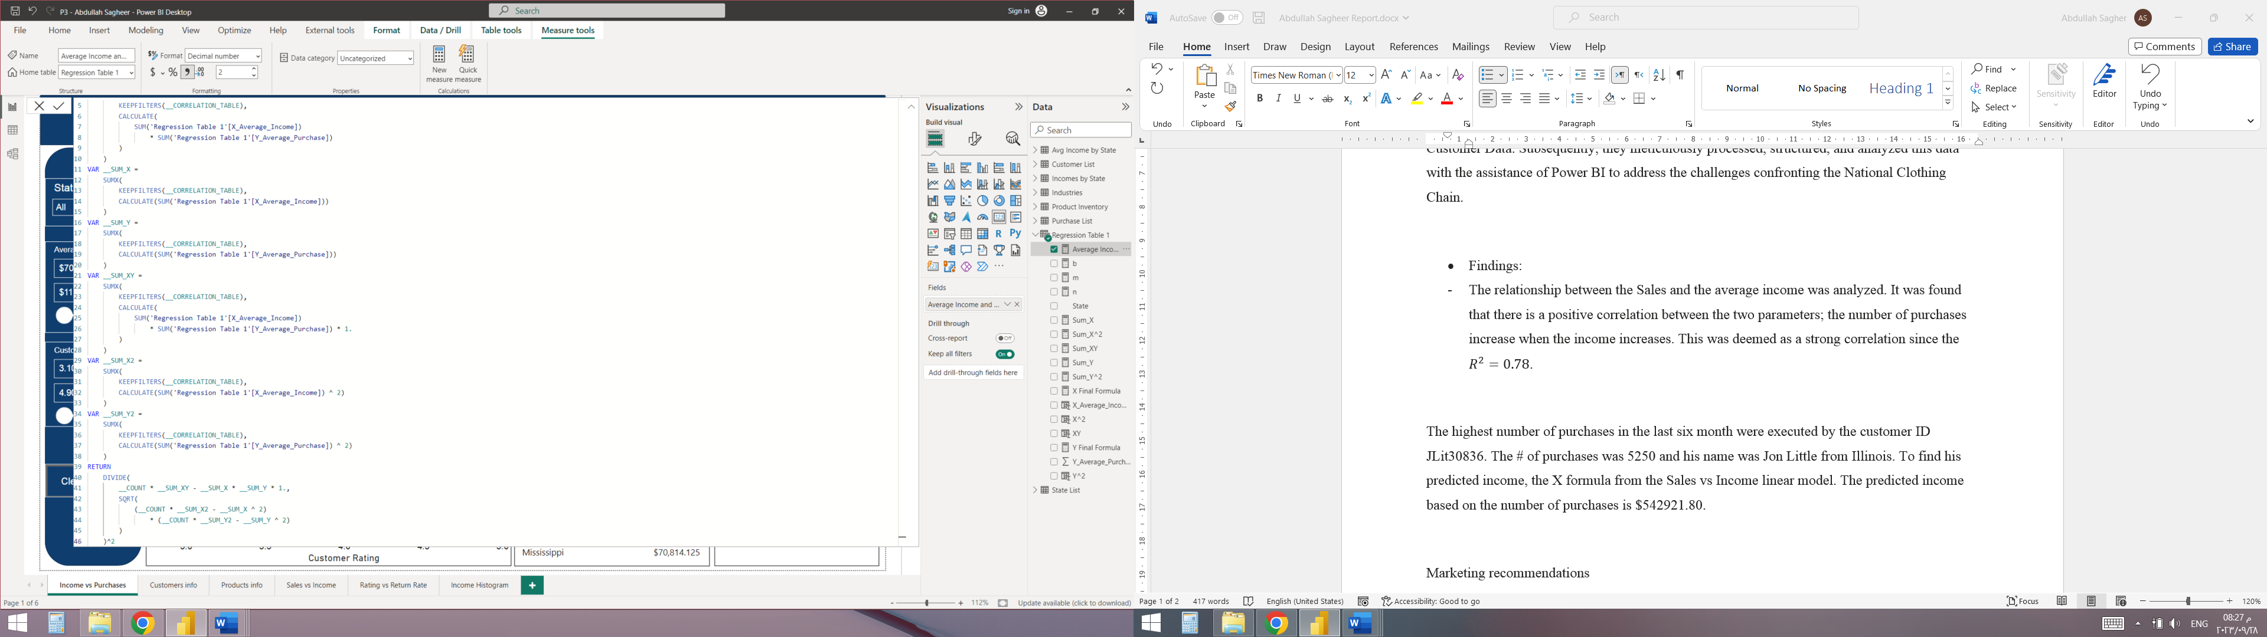

Figure 2: Sales vs income R2 DAX

* The relationship between the customer rating and the return rate of a product was also studied. The relationship was found to be negatively correlated was a high value of (**-0.83**).

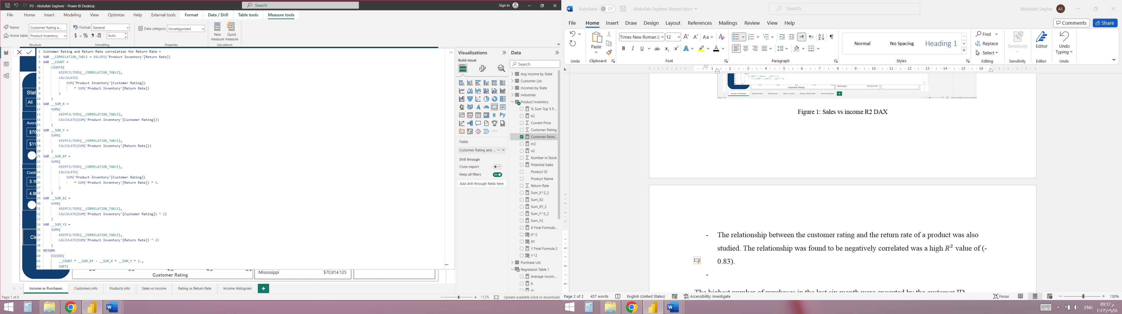

Figure 3: Customer rating vs return rate R2 DAX

* The top states by Income were District of Columbia, New Jersey, and Maryland. These states can be targeted for premium products sales. The bottom three states were: Arkansas, West Virginia, and Mississippi. The average income by state ranges between ~ $115,000 and ~$70,000.
* Using the linear regression relationship between the Income and sales, the customer number of purchases can be found using the following equation:

The customer Income can be found using the following equation:

* The highest number of purchases in the last six month were executed by the customer ID JLit30836. The # of purchases was 5250 and his name was Jon Little from Illinois. To find his predicted income, the X formula from the Sales vs Income linear model was used. The predicted income based on the number of purchases is **$542921.80**.

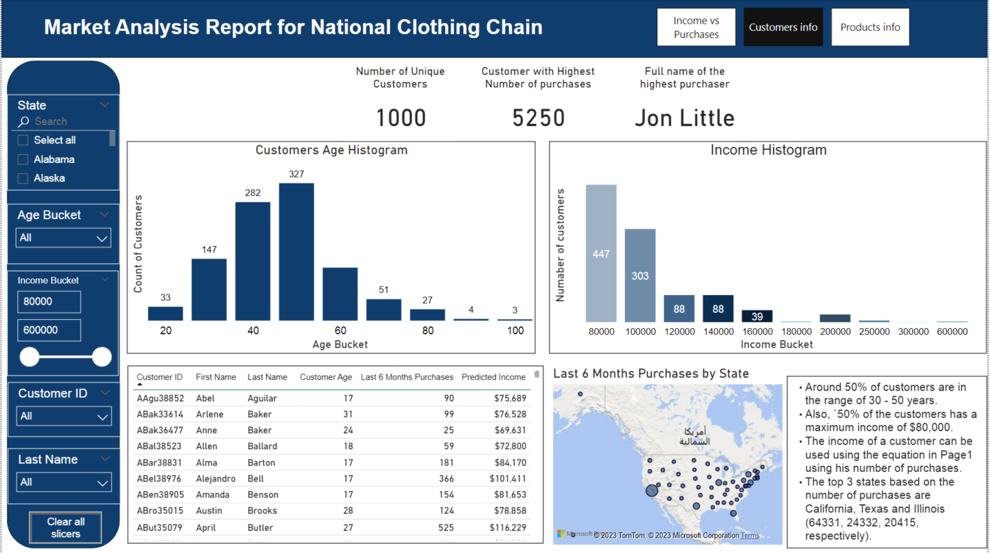

Figure 4: Report's page 2

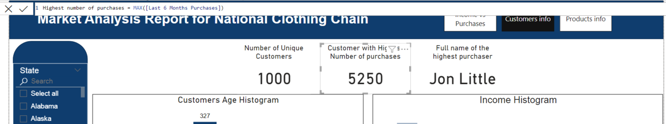

Figure 5: Highest number of purchases

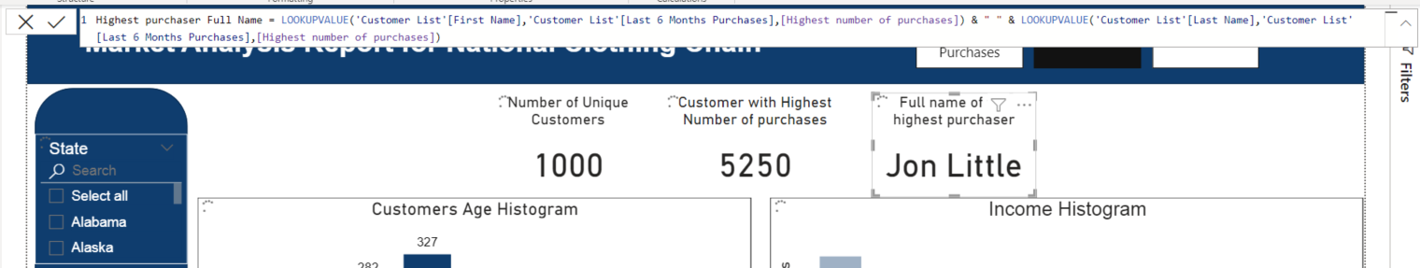

Figure 6: Highest purchaser full name



Figure 7: Predicted income DAX

* Around 50% of customers are in the range of 30 - 50 years. Also, ~50% of the customers has a maximum income of $80,000. The income of a customer can be used using the equation in Page1 using his number of purchases. The top 3 states based on the number of purchases are California, Texas and Illinois (64331, 24332, 20415, respectively).
* Marketing recommendations:
* The long dress should be considered. This product is #3 in customer rating with 4.50 stars. It has a fair price point, and it is affordable for all customers with different incomes. More importantly, it has the highest stock number with 373 pieces sitting idle waiting to be purchased by customers. In short, the long dress should be marketed because it already received a high customers satisfaction feedback, and it has one of the highest potential earnings due to the high stock and good price.
* The second recommend product is the leather bag. However, few notes should be considered. The price is a little high and a reduction in the price could be used as part of the marketing campaign. Also, the customers’ rating is good but not enough, thus the quality should be enhanced. This product could still generate the highest earnings even with a 50% discount with current stock and price. The same can be said about the sweater dress, except that the price shouldn’t be changed in this case.
* Chronograph watch has the highest rating and obviously people are liking this product. The price seems fair and increasing the production of this item is guaranteed to generate a huge cash flow. Thus, it is recommended to market this watch and immediately start increasing the inventory.

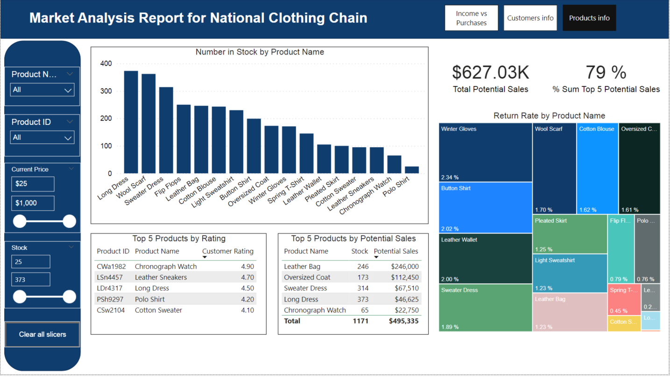

Figure 8: Report's page 3

* The total potential sales based on the available stock and the current products’ prices is $627.03K. The top 5 product by potential earnings accumulate to 79% of the total potential earnings.
* Appendix

This section is to present the screen shots of the process.

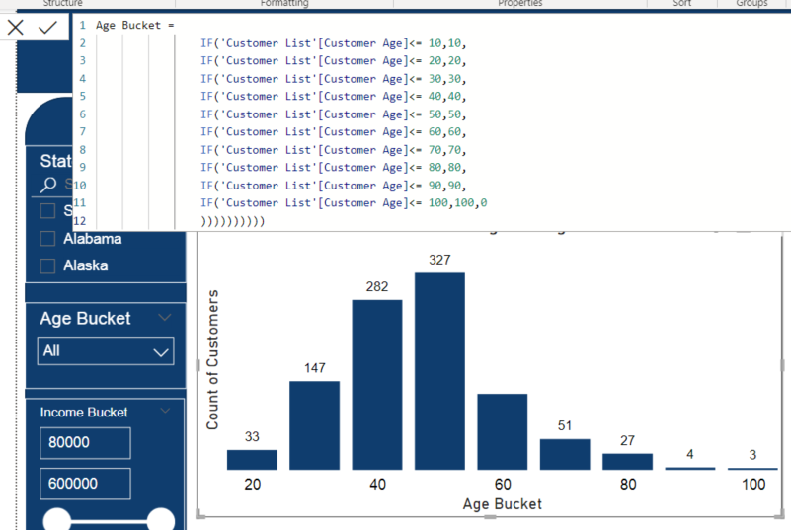

Figure 9: Age histogram

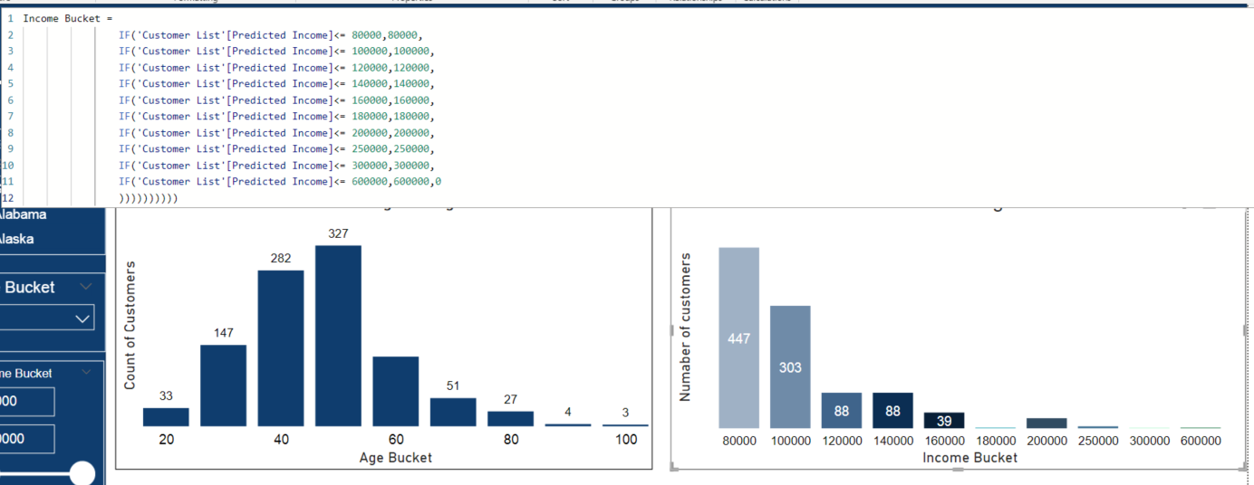

Figure 10: Income Histogram

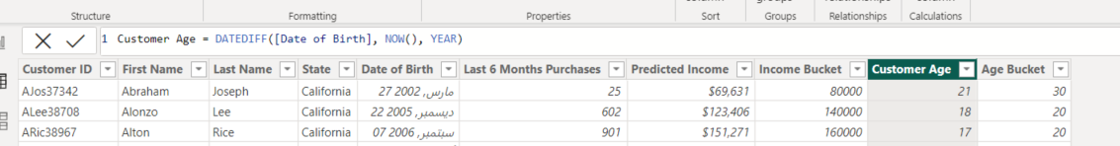

Figure 11: Customer age

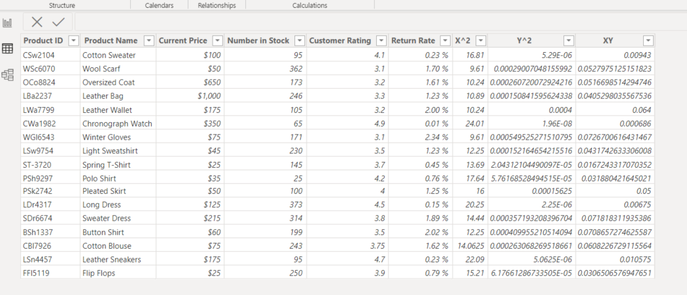

Figure 12: regression table for customer rating vs return rate

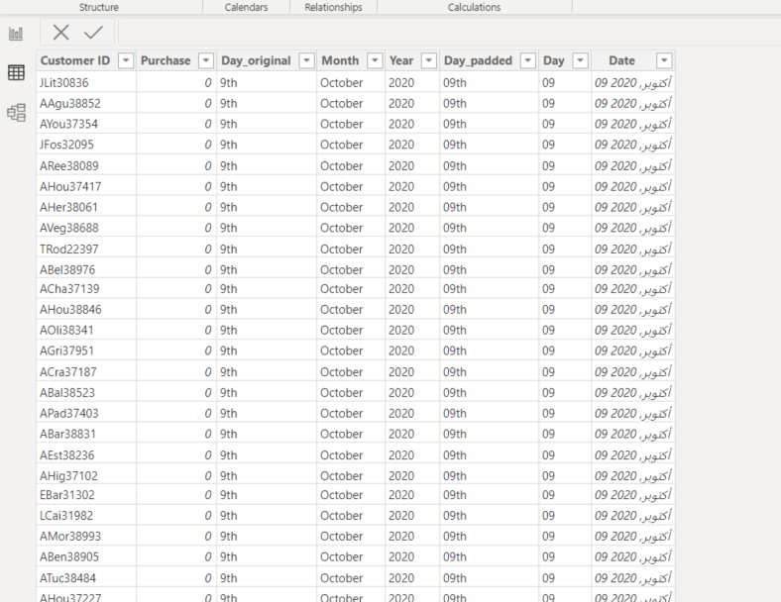

Figure 13: Purchases list

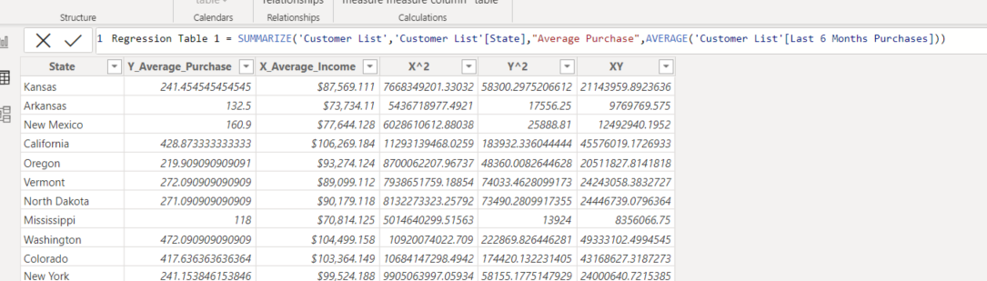

Figure 14: Regression table for the Income vs sales